2024
Open Team Sailing National Championships

Saturday 1st June to Monday 3rd June 2024

Royal Akarana Yacht Club, Okahu Bay

Notice of Race

The Organising Authority is the Royal Akarana Yacht Club in conjunction with the New Zealand Open Team Racing Association Inc.

1.0 Rules

1.1 The event will be governed by the ‘rules’ as defined in the Racing Rules of Sailing 2021-2024, including Appendix D.

1.2 The Yachting New Zealand Safety Regulations Part 1 shall apply.

2.0 Changes to Racing Rules

The Racing Rules will be changed in accordance with RRS 86 as follows:

2.1 In RRS D1.2(d)(1) and RRS D2.4(c) change “black and white” to “black”.

2.2 In RRS D 5.2, change “red” to “yellow”.

3.0 Eligibility

3.1 Entries will be accepted from teams of six sailors of any age or gender, all of whom shall be members of a yacht club affiliated to YNZ. By entering this event each team member will become automatic members of the New Zealand Open Team Sailing Association Incorporated with membership included in this entry fee.

3.2 The two crew members of each boat shall weigh a minimum of 130kg combined body weight, except that crews between 110kg and 130kg may make up their weight to 130kg with a maximum of 20kg in approved sand filled bottles which shall be fixed in the boat near the mast step. Maximum of 10kg per bottle. These bottles shall be marked in waterproof ink with the team name, weight and crew combination requiring the weight. If a crew combination is close to or under the weight limitation, the team members shall be weighed in normal dry sailing gear.

3.3 Entries will be accepted until the closing date of May 31st 2023, by submitting the entry form online on the RAYC website and paying the entry fee of $750.

3.4 A damage deposit of $500 per team is required and must be lodged with the entry fee. In the event of a team causing major damage to a boat or boats, exceeding $500, they will be required to pay an additional amount to cover the cost of that damage. If they wish to continue competing in the event a further deposit of $500 will be required.

4.0 Boats and Equipment

4.1 The event will be sailed in 420 type yachts. Spinnakers and trapezes will not be permitted. NZOTRI will coordinate the supply of all the 420 type yachts required for the event. Boats will be allocated according to a draw and shall not be modified except as set out in the Sailing Instructions.

4.2 Boats will be fitted with specific mainsails, being 200mm shorter in the leech than a standard 420 main and the size of a Sunburst class main when reefed, and coloured standard sized jibs. Mains will be reefed at the Race Officers discretion. All boats will be equalized as much as possible.

4.3 Red protest flags and yellow break down flags will be supplied. You are also permitted to supply your own.

4.4 Buoyancy vests must be worn by competitors and supporters at all times while afloat.

5.0 Schedule of Events

Saturday 1st June 08:30 Registration & Weigh in
Saturday 1st June 09:00 Briefing
Saturday 1st June 09:45 Time of first warning signal
Sunday 2nd June 09:30 Time of first warning signal
Monday 5th June 09:30 Time of first warning signal
Prizegiving - Approx 30min after last boat gets ashore

6.0 Sailing Instructions

Sailing instructions will be available from May 30th on the official noticeboard which is located at the Royal Akarana Yacht Club. They will also be posted on the NZ Open Team Racing Nationals Facebook page.

7.0 Racing Area

The races will be held in Okahu Bay.

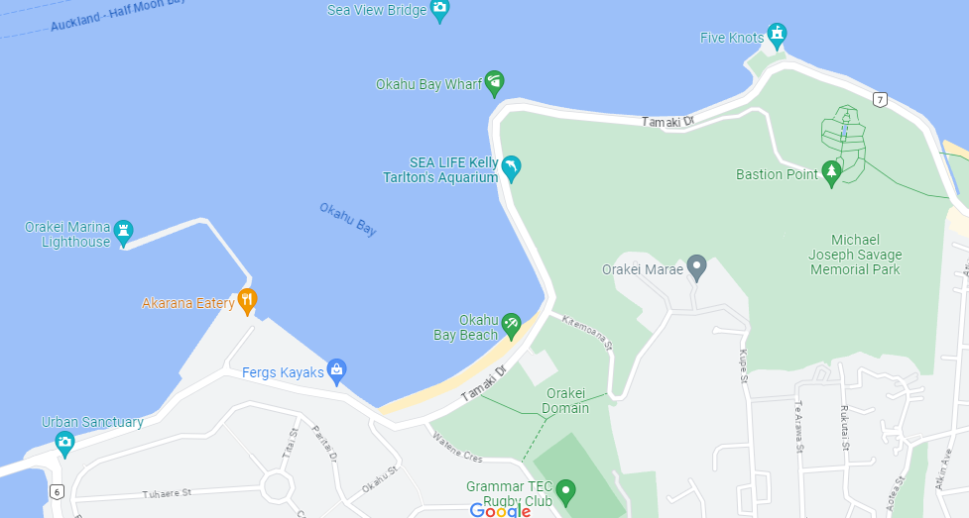

8.0 Courses and Racing Format

8.1 The course will be an S shape with starboard rounding of the first mark.

8.2 The series will consist of a number of round robin races, with a knockout finals series to determine the winner. The intention is to have all teams involved in the knockout finals series.

9.0 Scoring

9.1 Scoring will be in accordance with RRS Appendix D3 and D4.

10.0 Prizes

The winning team will be awarded the New Zealand Open Team Racing National Championship Trophy.

11.0 Support Boats

Support boats will be allowed but must operate in accordance with the Race Officer’s instructions.

Each team shall nominate one team member to be their nominated changeover driver in order to facilitate teams moving to and from the course. This team member agrees to abide by any and all safety instructions and policies put forward by RAYC.

12.0 Disclaimer and Liability

12.1 RRS 3 states: ‘The responsibility for a boat’s decision to participate in a race or to continue to race is hers alone.’ By participating in this event each competitor agrees and acknowledges that sailing is a potentially dangerous activity with inherent risks. These risks include strong winds and rough seas, sudden changes in weather, failure of equipment, boat handling errors, poor seamanship by other boats, loss of balance on an unstable platform and fatigue resulting in increased risk of injury. Inherent in the sport of sailing is the risk of permanent, catastrophic injury or death by drowning, trauma, hypothermia or other causes.

14.0 Further Information

If you have any further enquiries please contact Jamie Catchpole at jamie@rayc.co.nz or Reuben Corbett corbett.reuben@gmail.com

